Media Release

XXXXXXX XX, 2020

For Immediate Release

ENTRANCE, VISITOR RESTRICTIONS EFFECTIVE IMMEDIATELY AT WRH

WINDSOR, ON. _ Windsor Regional Hospital has implemented immediate steps to protect the public and our staff from potential transmission of the COVID-19 virus.

The following restrictions are NOW IN EFFECT at both the Met and Ouellette campuses of WRH:

- LIMITED ENTRANCES AND SCREENING

Patients and visitors are limited to the following entrances ONLY to each campus:

Met Campus: Visitors may only enter from the main entrance (off Lens Ave.,), the Cancer Centre entrance (off Alsace Ave.), or the regular Emergency Department entrance (off Byng Rd.).

A COVID-19 ASSESSMENT CENTRE is located near the endoscopy area (off Byng Rd.)

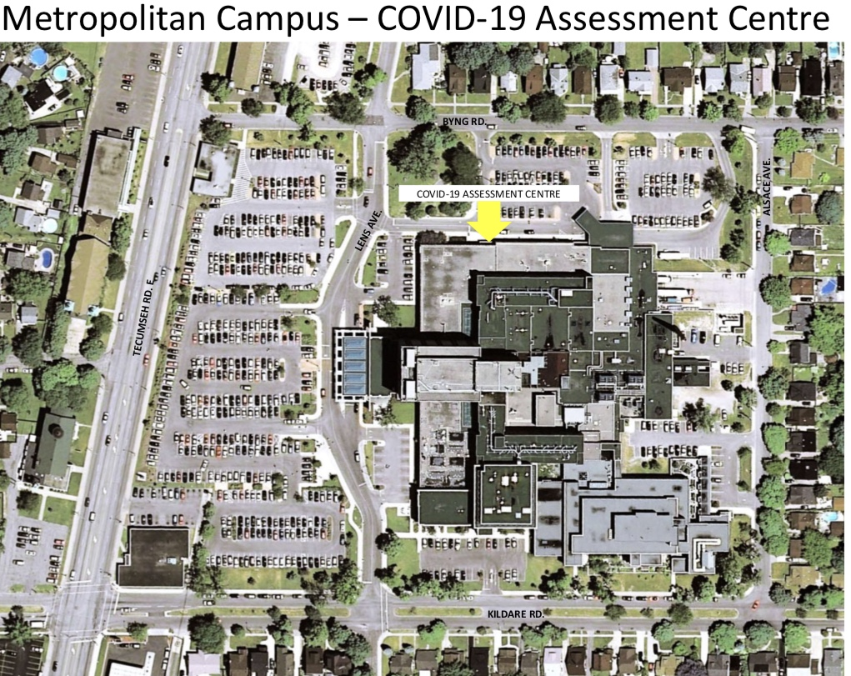

Ouellette Campus: Visitors may only enter from the main entrance (off Goyeau St.), the third level hallway from the parking garage, or the regular Emergency Department entrance. Patients attending for dialysis appointments at the Bell building can enter from the east side main entrance. Patients coming to the Jeanne Mance building can also use the east entrance. THERE IS NO ACCESS TO THE HOSPITAL FROM OUELLETTE AVE.

A COVID-19 ASSESSMENT CENTRE is located at the outpatient clinic entrance (off Goyeau St.)
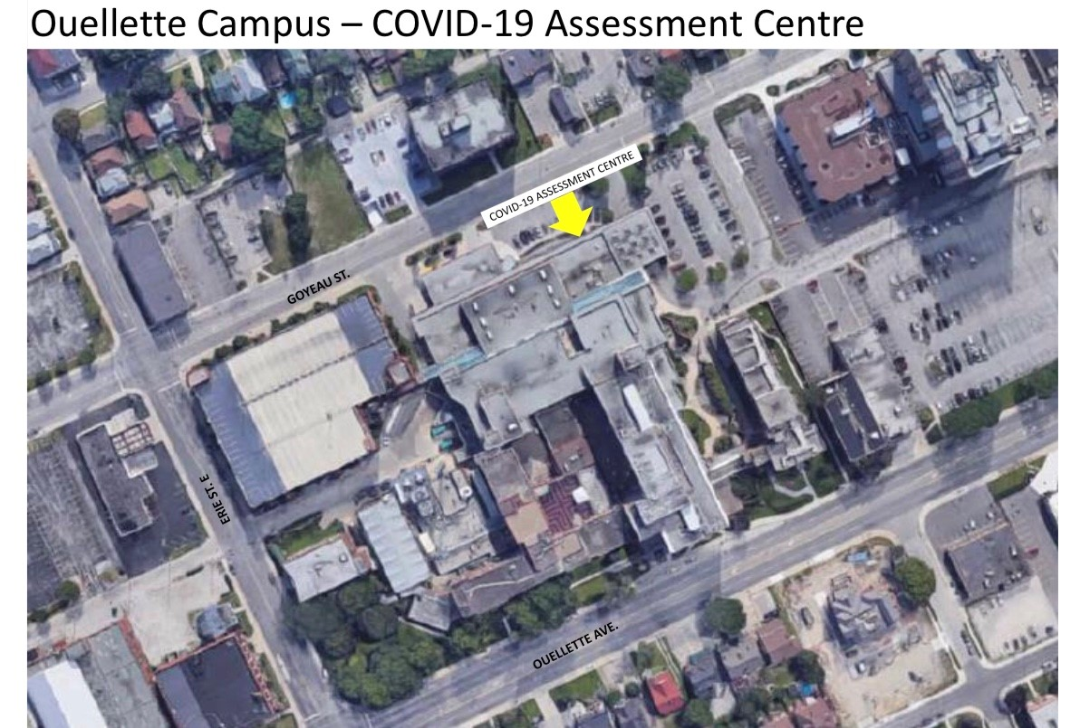

At EACH of these entrance points, ALL patients and visitors will be assessed for potential COVID-19. At the COVID-19 ASSESSMENT CENTRE patients will be questioned about current health and recent travel, as well as a check of each individual’s temperature. Further assessment may be required at the discretion of the health care team.
RESTRICTIONS TO NUMBER OF VISITORS PER PATIENT

Effective immediately, ONLY the following visitors are allowed per patient:
- TWO visitors for paediatrics patients
- TWO visitors for patients in critical care/Neonatal Intensive Care
- ONE visitor for maternal patients before or after giving birth
- ***TWO visitors for palliative care patients

NO OTHER VISITORS TO IN-PATIENT ROOMS WILL BE PERMITTED.
*** We are prepared to make special exceptions to the visitor policies above on compassionate grounds, but only at the request and approval by the patient, and in consultation with the care team and our infection control team.

“These measures are being implemented as part of our best efforts to limit the potential transmission of the COVID-19 virus from person to person,” said David Musyj, President and CEO, Windsor Regional Hospital. “They are taking effect to protect you, and your loved ones, whether they are our patients, our visitors, or our staff. As we have communicated previously, if you are ill with a respiratory infection, DO NOT come to hospital where you may risk transmitting this virus to another individual. If you are unsure whether you have contracted the COVID-19 virus, contact your primary care provider, medical clinic or the Windsor-Essex Public Health Unit 519 258 2146 ext. 1420, or call Telehealth at 1-866-797-0000 (24 hours, seven days a week).”

Windsor Regional Hospital will continue to update the public regarding any changes to policies and procedures until the pandemic declaration has been lifted by the Province of Ontario.

-30-
For further information contact:
Steve Erwin, Manager, Corporate Communications, Government and Community Relations
519-564-4902 (cell) / steve.erwin@wrh.on.ca

